Vehicle Analytics Platform
System Architecture Overview
The platform processes video into actionable traffic and vehicle intelligence through an eight-stage pipeline. Each stage consumes the output of the one before it, so a failure or delay at any point (e.g. a missed detection) propagates forward and is compensated for by the stage that follows (e.g. the tracker's lost-track buffer).
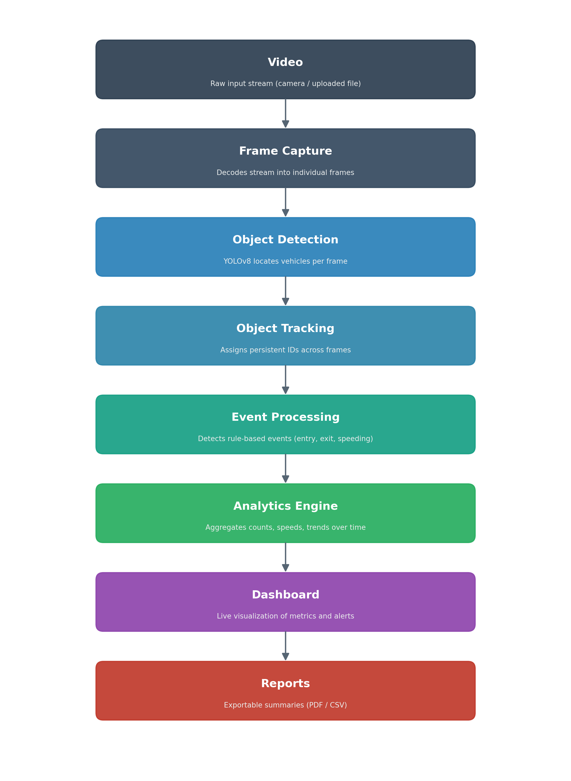
Figure 1: End-to-end processing pipeline

Component Breakdown
1. Video
The raw input source.
The pipeline accepts a live webcam feed or an uploaded video file. This is the only stage with no dependency on earlier processing — it simply supplies a continuous stream of frames to the rest of the system.
2. Frame Capture
Turns the stream into individual, timestamped frames.
Reads frames sequentially from the source, resizes/normalizes them as needed, and hands each frame to the detector on a fixed cadence. This decouples the input source (camera vs. file) from everything downstream, so the rest of the pipeline works identically regardless of where the video came from.
3. Object Detection
Locates vehicles in each individual frame.
A YOLOv8 model runs on every frame at a low base confidence threshold, producing bounding boxes and class labels (car, bus, truck, motorcycle, etc.). Running detection at a permissive confidence deliberately over-generates candidate boxes, since it is the tracker — not the detector — that decides which detections are trustworthy enough to become a tracked object.
4. Object Tracking
Turns per-frame detections into persistent identities.
ByteTrack matches detections across consecutive frames and assigns each vehicle a stable track ID. A track only "locks in" after being consistently matched for several frames (filtering out one-off false positives), and a lost-track buffer keeps a locked track alive through brief occlusions or missed detections instead of dropping it immediately. Each vehicle class also gets its own ID numbering series, so IDs stay unambiguous across vehicle types.
5. Event Processing
Converts raw tracks into meaningful occurrences.
Track positions are evaluated frame-by-frame against configured rules — a counting line, a region of interest, a speed threshold — to generate discrete events such as "vehicle entered," "vehicle exited," or "line crossed." This is the layer that gives tracking data business meaning rather than just coordinates.
6. Analytics Engine
Aggregates events into metrics over time.
Events are rolled up into running statistics: per-class counts, throughput over time, average dwell time, and speed distributions. This stage maintains state across the whole session so metrics are cumulative rather than reset per frame.
7. Dashboard
Presents live metrics to the user.
A web frontend renders the annotated video stream alongside real-time counters, charts, and alerts, updating continuously as new analytics arrive. This is the primary interface for monitoring the system while it runs.
8. Reports
Produces a durable record of a session.
On demand, accumulated analytics are exported into shareable summaries (e.g. CSV/PDF), giving a persistent artifact of what the dashboard showed live — useful for audits, comparisons across sessions, or sharing with stakeholders who weren't watching the live feed.

